Previewing Evidence

We can preview the files and folder present in evidence item. FTK Imager provides us three modes for perviewing the electronic data of the evidence item. These modes are:

* Automatic(IE)
* Text
* Hex

We can select any of the mode of our choice from:

* Mode menu.

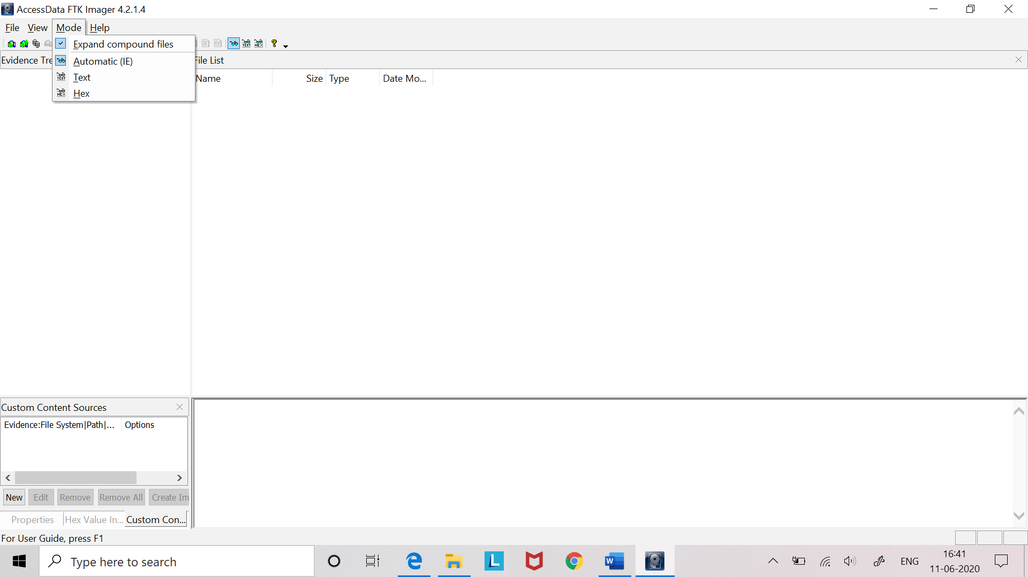

* Toolbar.



#### Automatic Mode

Automatic mode automatically chooses the best method for previewing a file’s contents, according to the file type. For example:

* Web pages, Web-related graphics (JPEGs and GIFs), and any other media types for which Internet Explorer plug-ins have been installed are displayed by an embedded version of Internet Explorer in the Viewer.
* Text files are displayed in the Viewer as ASCII or Unicode characters.
* File types that cannot be viewed in Internet Explorer are displayed outside of FTK Imager in their native application provided those applications are installed locally, and the appropriate file associations have been configured in Windows.

File types that cannot be viewed in Internet Explorer and that do not have a known native viewer are displayed by default in Hexadecimal Mode in the Viewer.

#### Text Mode

Text mode allows us to preview a file’s contents as ASCII or Unicode characters, even if the file is not a text file. This mode can be useful for viewing text and binary data that is not visible when a file is viewed in its native application.

#### Hex Mode

Hex mode allows us to view every bite of data in a file as hexadecimal code. We can use the Hex Value Interpreter to interpret hexadecimal values as decimal integers and possible time and date values.

**Note:** Preview modes apply only when displaying file data. The data contained in folders or other non-file objects is always displayed in hexadecimal format.